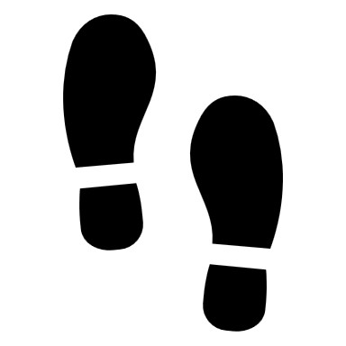

SHOES STRICTLY

PROHIBITED

土足厳禁