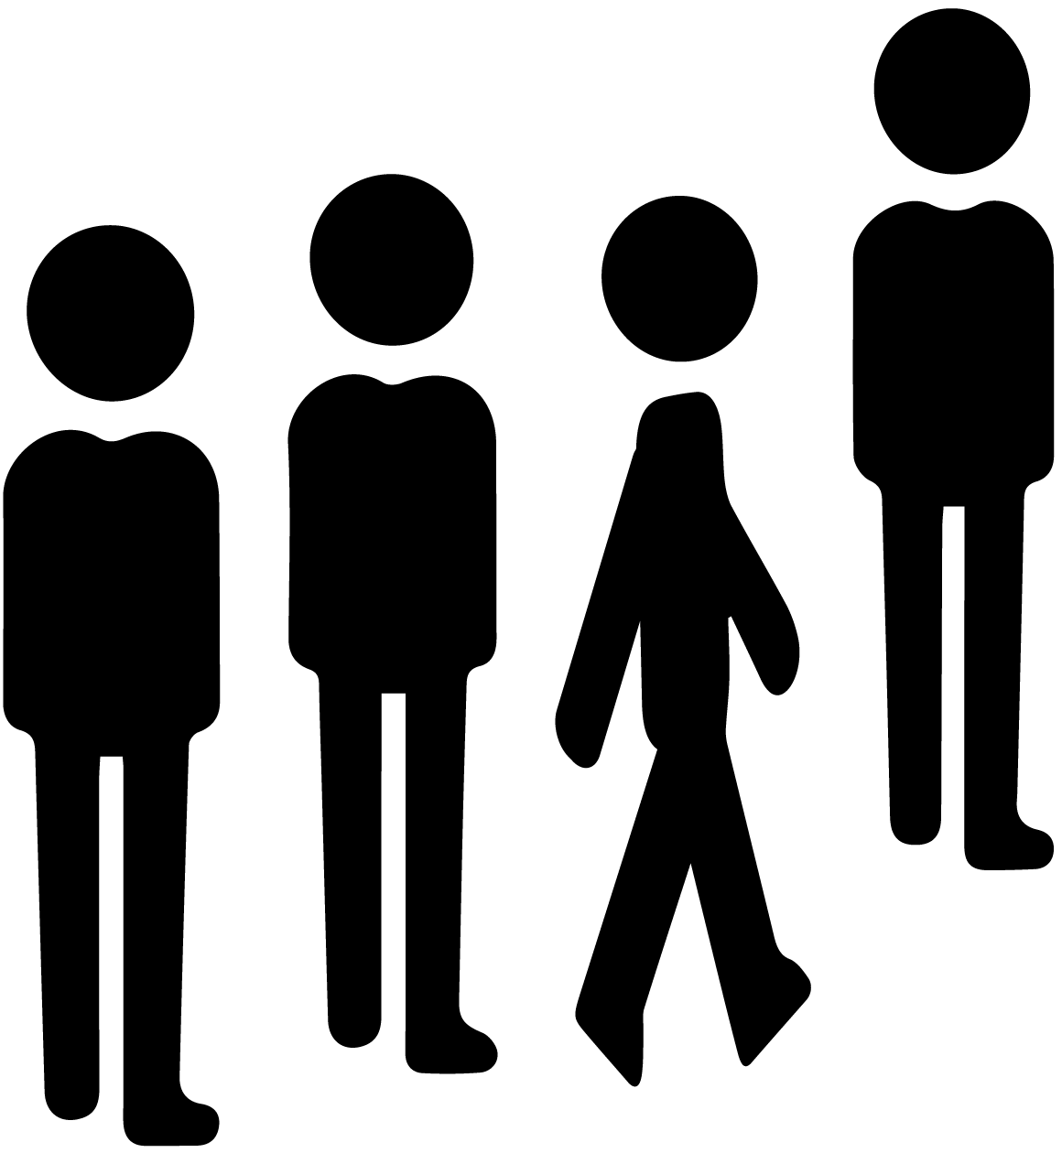

**PLEASE QUEUE** UP

**NO LINE JUMPING**

**A fine of 100 dollars will be imposed for violations.**