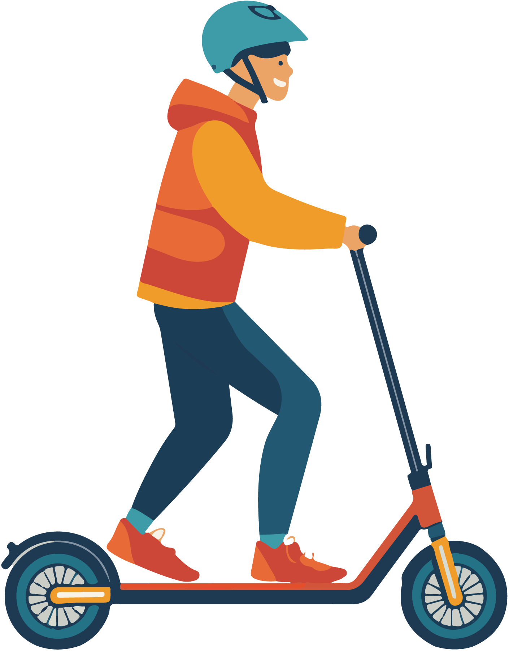

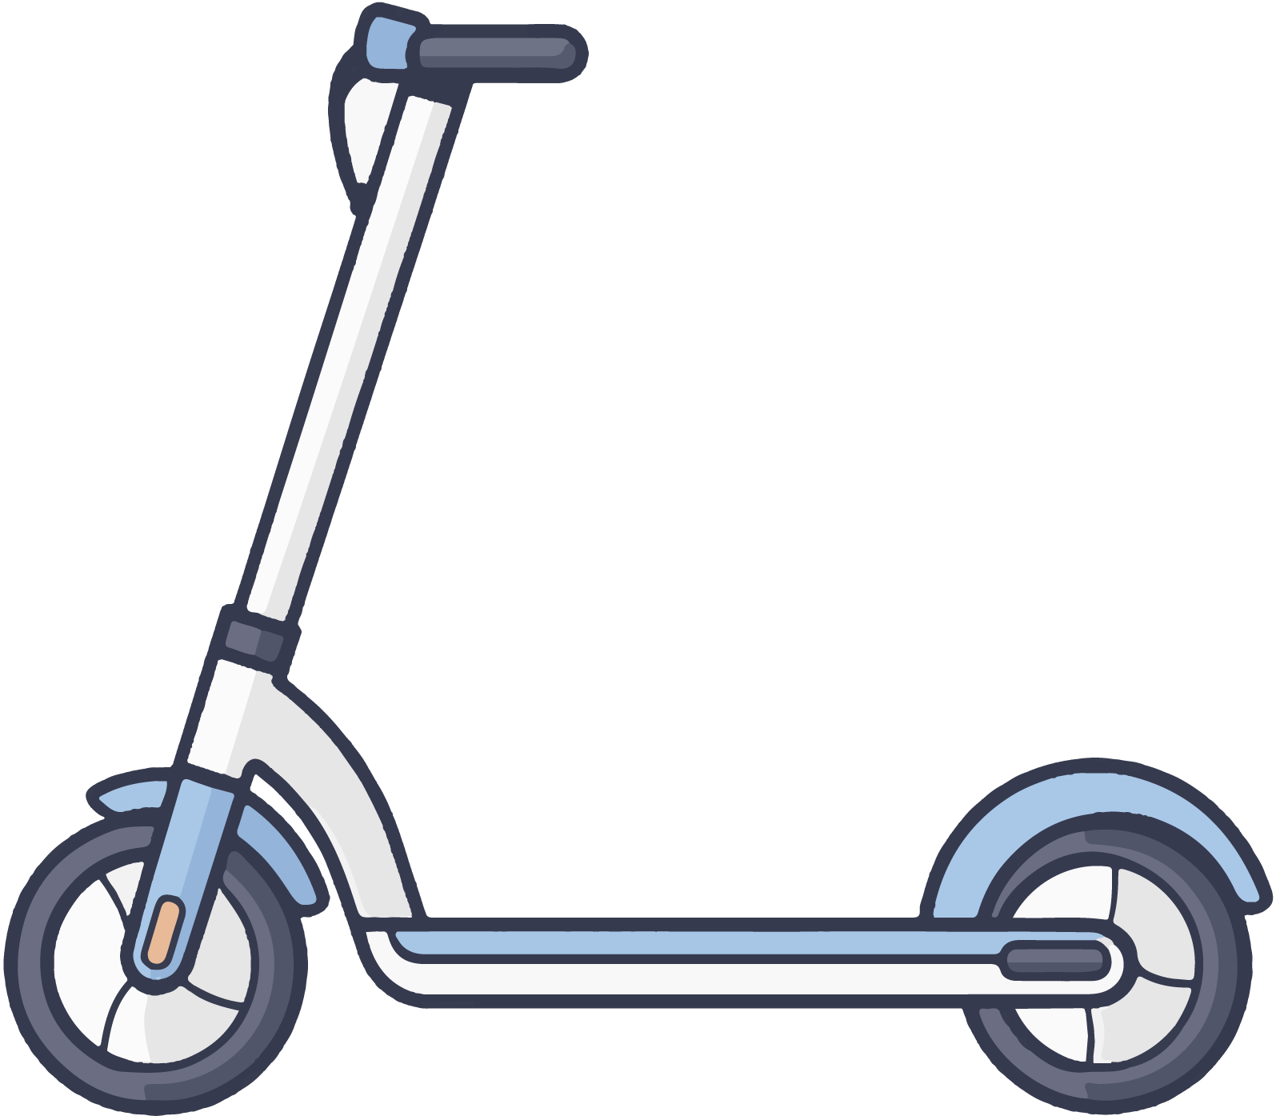

**禁止使用电子滑板车**

**NO ELECTRIC KICKBOARDS**

**A fine of 100 dollars will be imposed for violations.**

**违反规定者将被处以500元的罚款。**