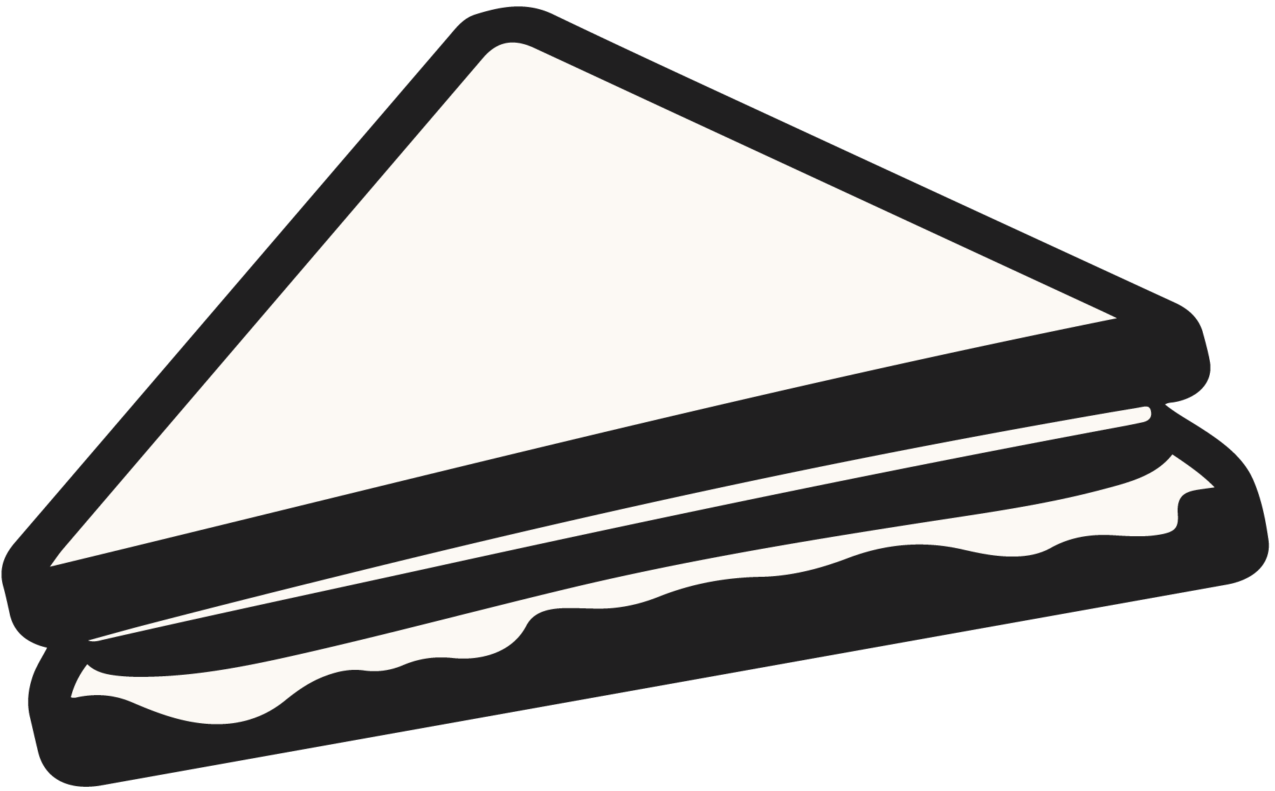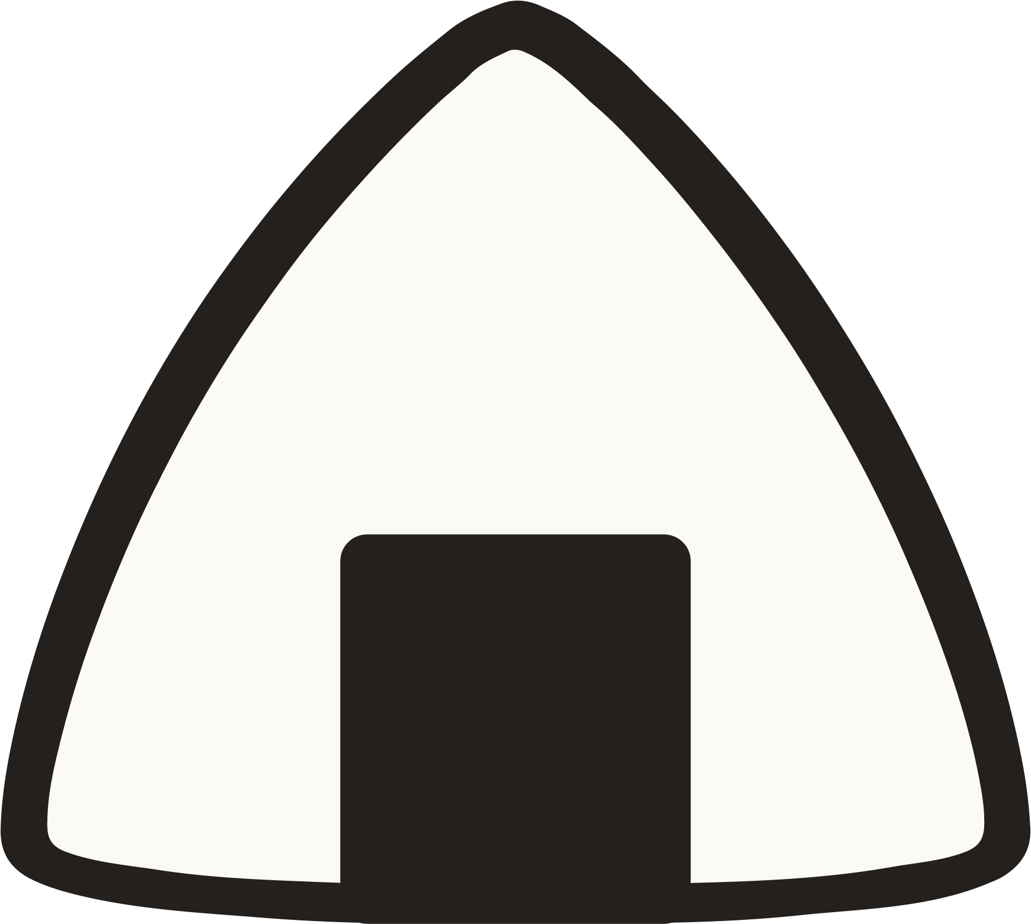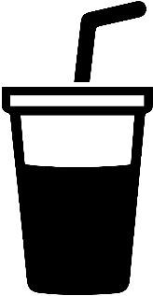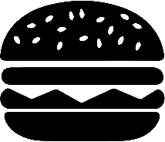

**付款前禁止饮食**

**NO EATING OR DRINKING**

**BEFORE SETTLEMENT**

**A fine of 100 dollars will be imposed for violations.**

**违反规定者将被处以500元的罚款。**