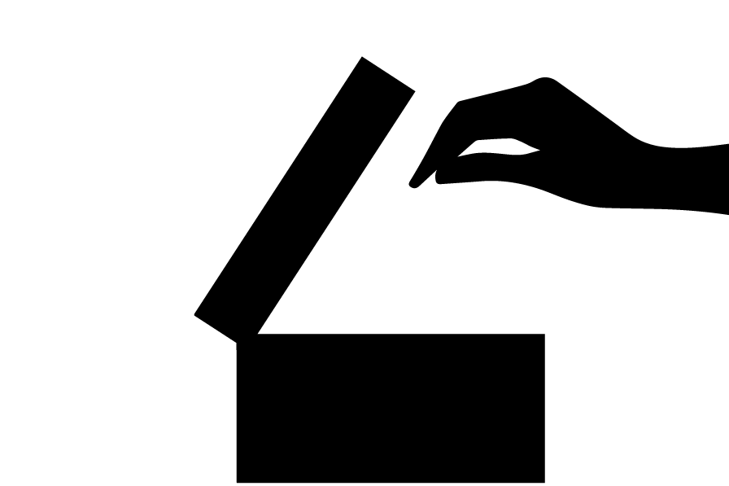

**结账前清不要打开包装**

**DO NOT OPEN ANY STORE ITEMS PRIOR TO PURCHASING**