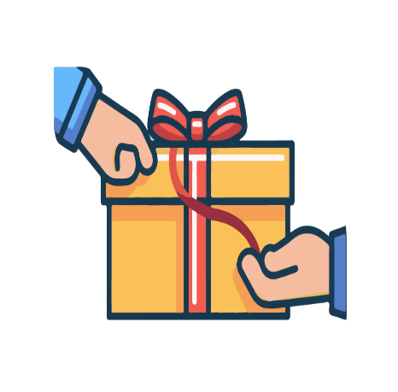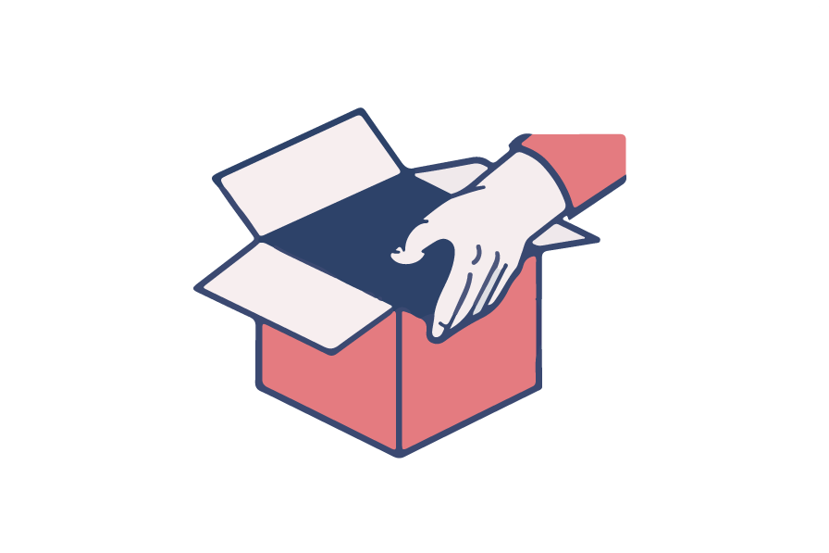

**DO NOT OPEN ANY STORE ITEMS PRIOR TO PURCHASING**

**A fine of 100 dollars will be imposed for violations.**

**违反规定者将被处以500元的罚款。**

**结账前清不要打开包装**