**禁止非法倾倒**

**NO ILLEGAL**

**DUMPING**

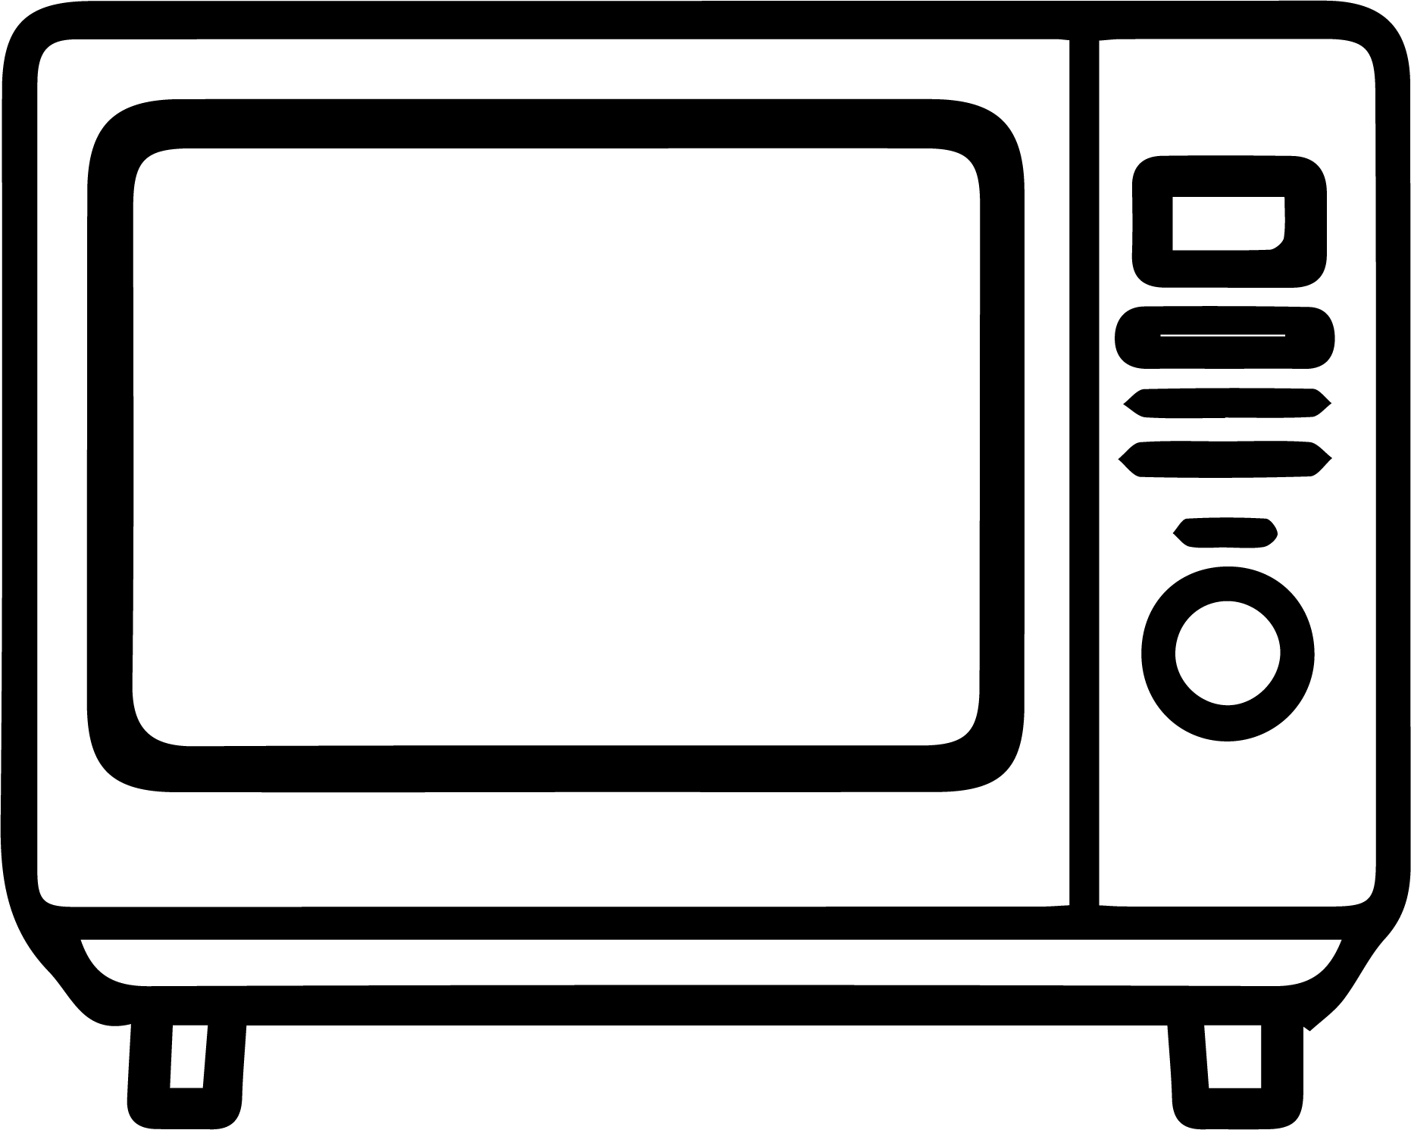

**A fine of 100 dollars will be imposed for violations.**

**违反规定者将被处以500元的罚款。**