NO OFF-LEASH

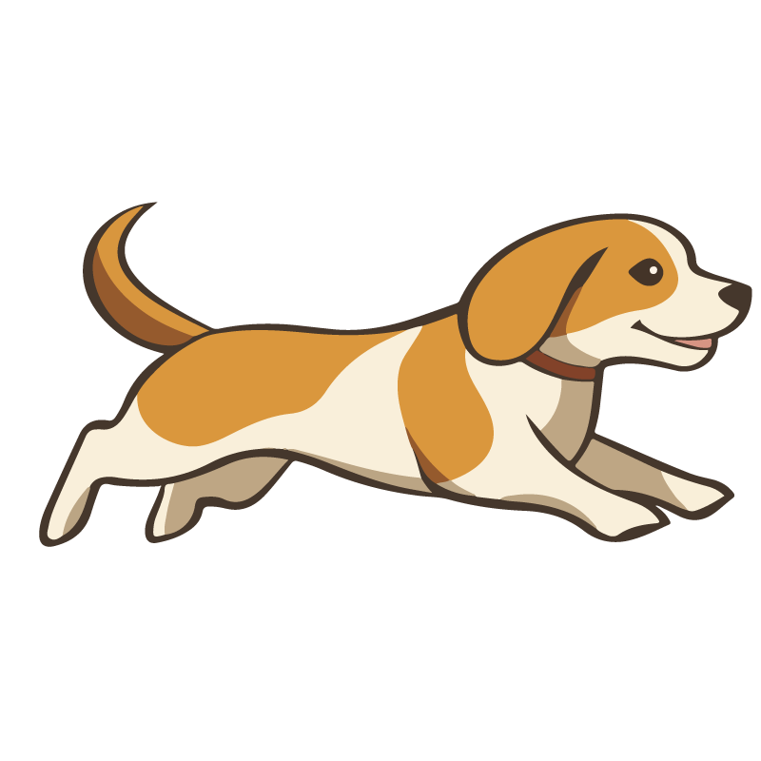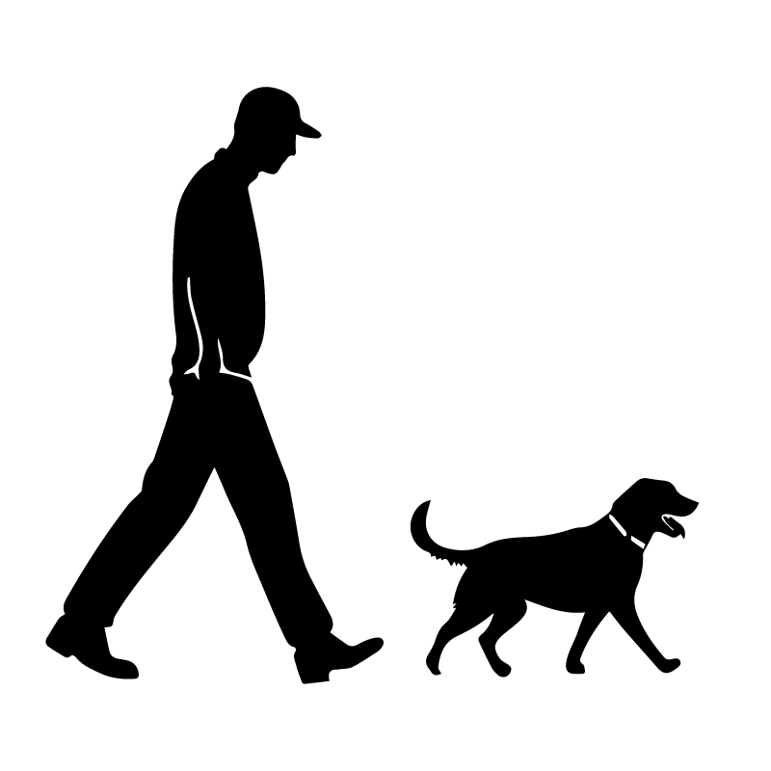

**禁止不牵绳遛**

**A fine of 100 dollars will be imposed for violations.**

**违反规定者将被处以500元的罚款。**