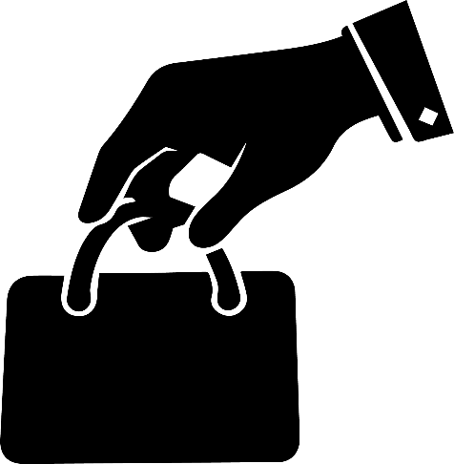

BEWARE OF THEFT

**Please do not leave your valuables unattended.**

**请勿将贵重物品放置无人看管。**

注意盗窃

