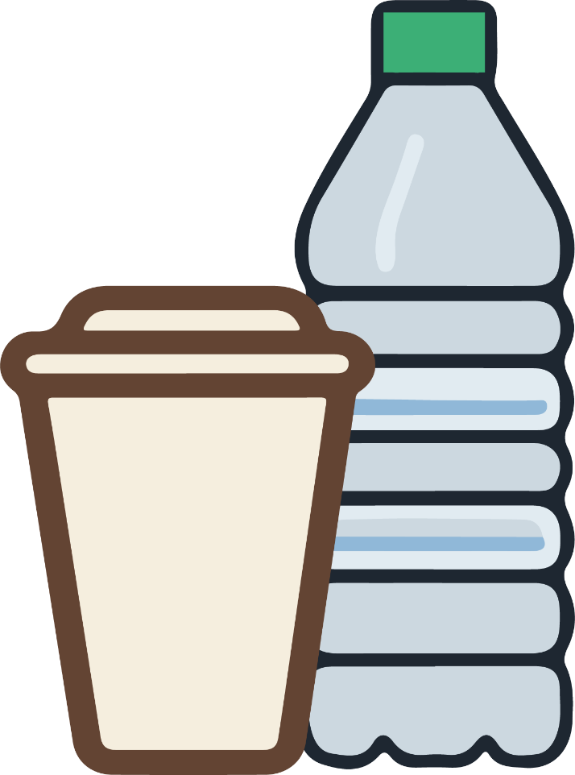

**禁止携带饮料**

NO DRINKS ALLOWED