飲み物持込禁止

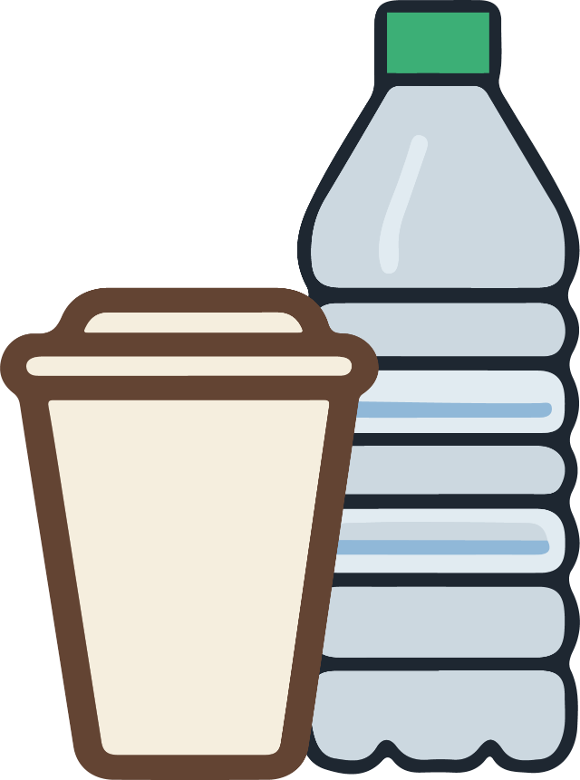

NO DRINKS

ALLOWED

**禁止携带饮料**