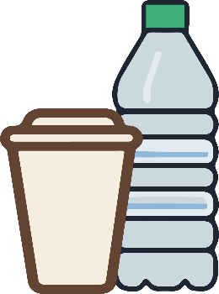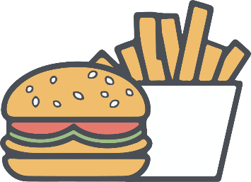

**禁止携带饮食**

NO FOOD OR

DRINK ALLOWED

**A fine of 100 dollars will be imposed for violations.**

**违反规定者将被处以500元的罚款。**