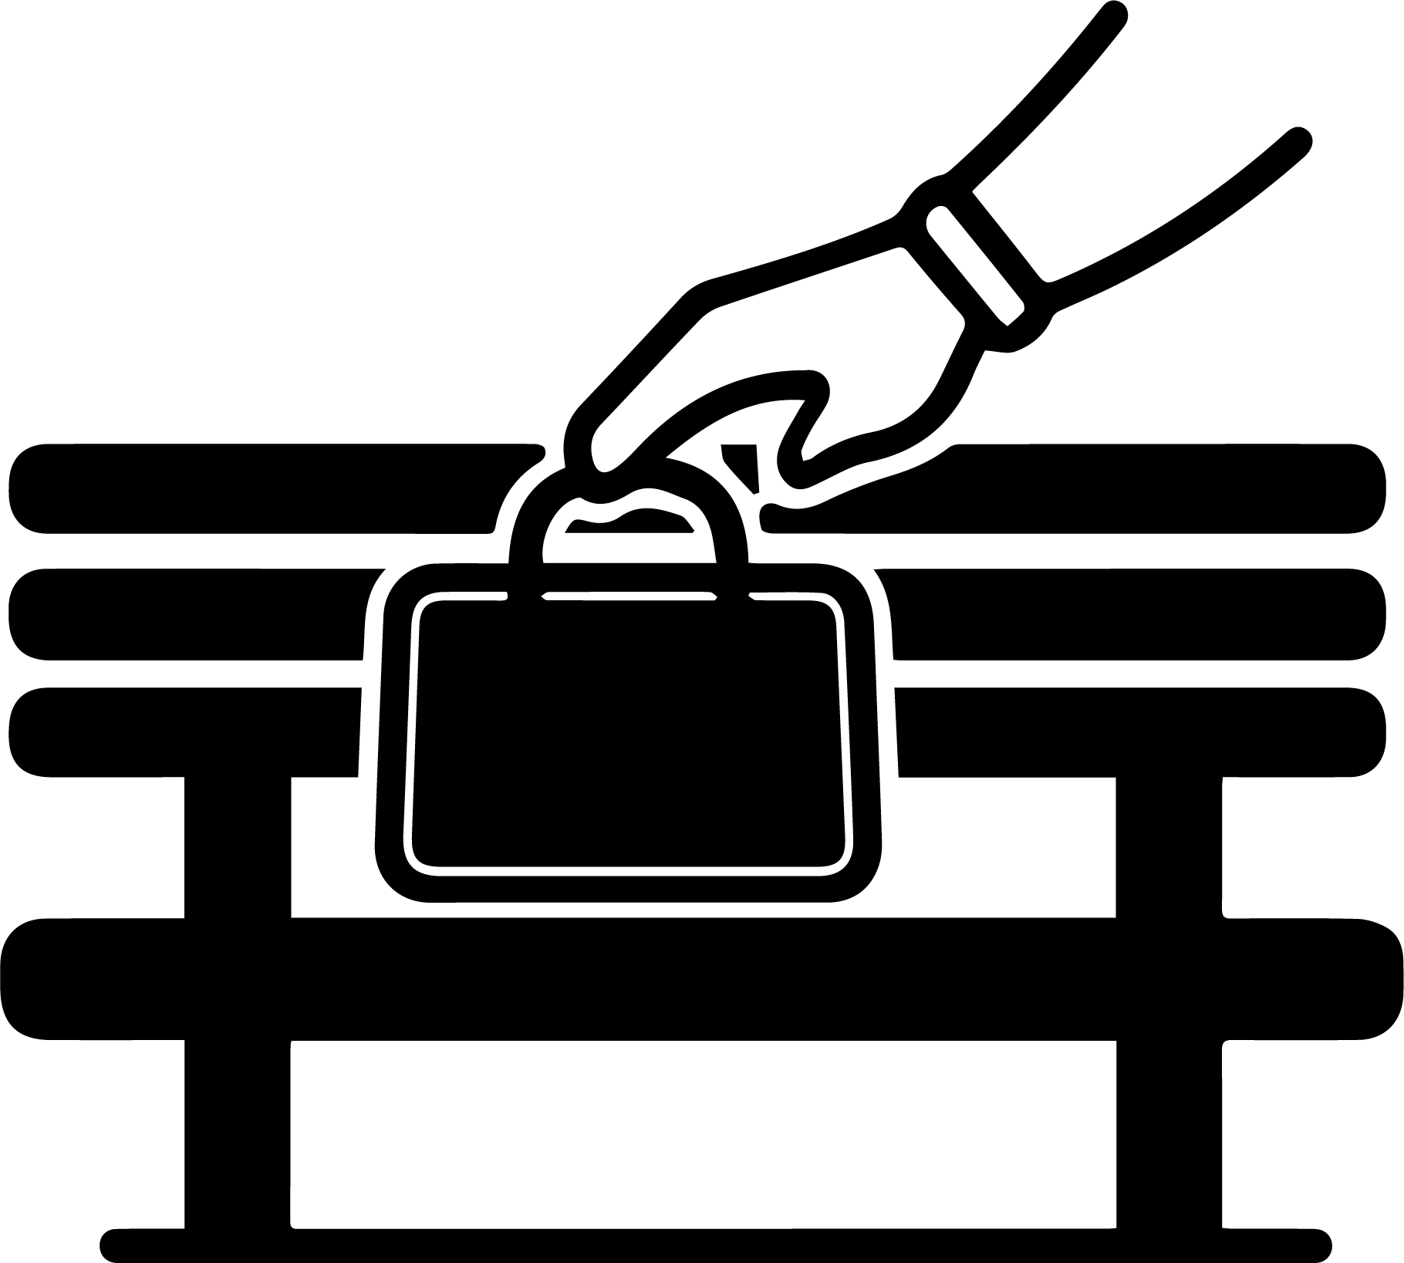

**WATCH OUT FOR THEFT**

**小心被偷**