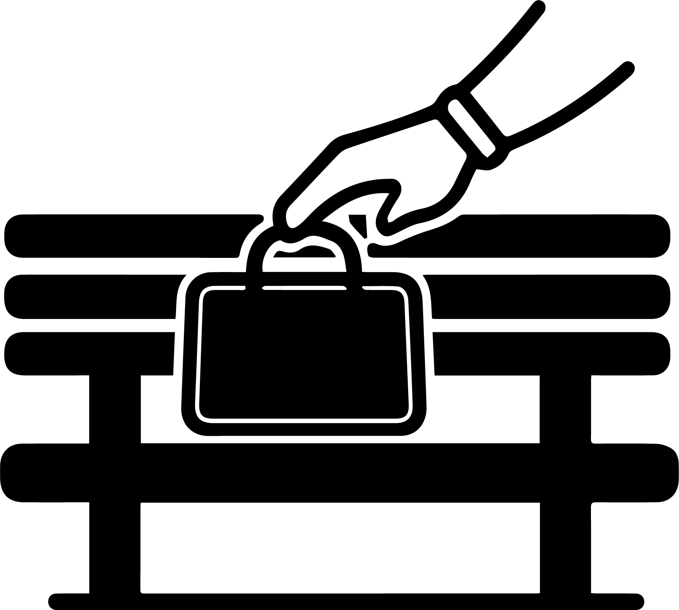

置き引き注意

**小心被偷**

**WATCH OUT FOR THEFT**