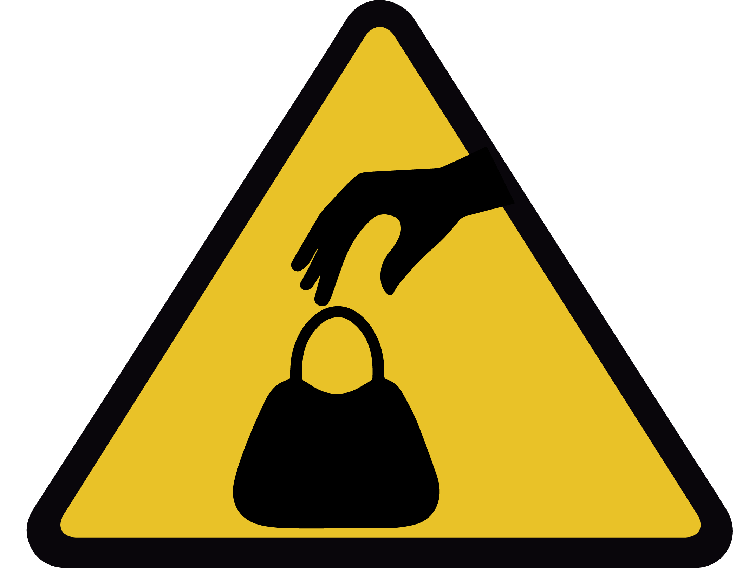

**小心被偷**

**WATCH OUT FOR THEFT**