**禁止边走边吃**

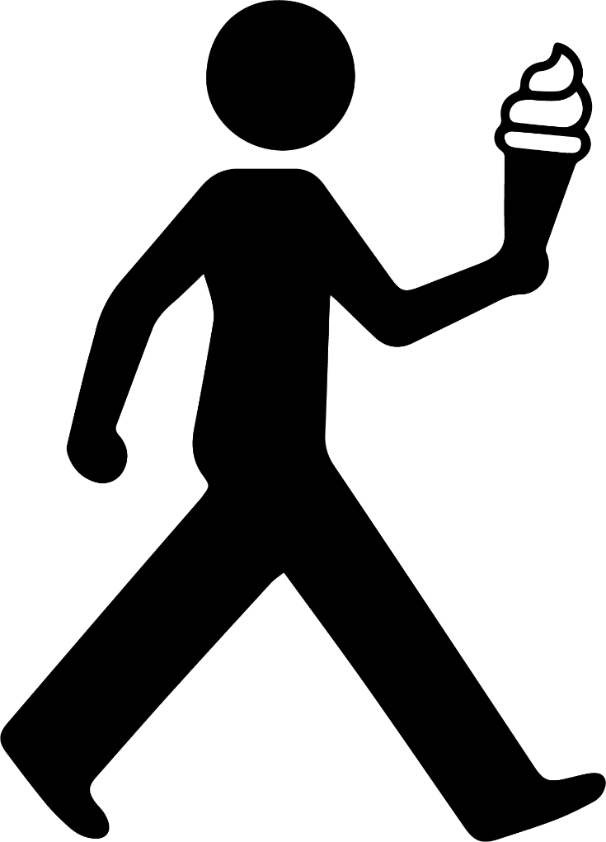

NO EATING

WHILE WALKING