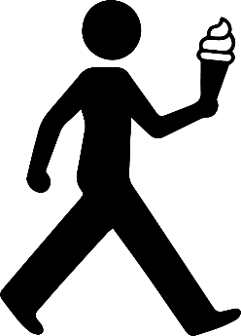

**禁止边走边吃**

NO EATING

WHILE WALKING



**A fine of 100 dollars will be imposed for violations.**

**违反规定者将被处以500元的罚款。**